Nursery Medium Term Planning Autumn 2 – It starts with me!

 | Week 1 | Week 2 |  |  | Week 3 | Week 4 | Week 5 |  | Week 6
Characteristics of Effective Learning | Lenny Lion’s learning zoo  Go for it Gorilla, Exploring Elephant, I know Rhino, Proud Peacock, Concentrating Crocodile, Persevering Parrot, Choosing Chimp, Creative Chameleon, Slinky Linky Snake
Communication & Language | Hey diddle diddle  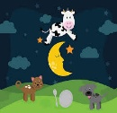 |  |  |  | Hickory dickory dock  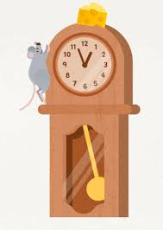 |  | 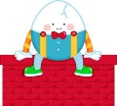  Humpty Dumpty
Dev Matters | Enjoy singing, music and toys that make sounds. Enjoy songs and rhymes, tuning in and paying attention. Join in with songs and rhymes, copying sounds, rhythms, tunes and tempo. Say some of the words in songs and rhymes. Copy finger movements and other gestures. Join in with songs and rhymes, making some sounds. Enjoy and take part in action songs, such as ‘Twinkle, Twinkle Little Star’. (B-3)  Sing a large repertoire of songs. Develop their phonological awareness, so that they can: - spot and suggest rhymes - count or clap syllables in a word - recognise words with the same initial sound, such as money and mother. Remember and sing entire songs. Sing the pitch of a tone sung by another person (‘pitch match’). Sing the melodic shape (moving melody, such as up and down, down and up) of familiar songs. Create their own songs or improvise a song around one they know. (3-4)
Phonics | s-snake | a-astronaut |  |  | t-tiger | p-penguin | i-iguana |  | n-net
2 year old focus activity | Dough disco | Science garden |  |  | stories and puppets | shaving foam and people | What’s in the box |  | Drawing to music
WellComm | Big Book | Big Book |  |  | Big Book | Big Book | Big Book |  | Big Book
Dev Matters | Copy your gestures and words. Play with increasing confidence on their own and with other children, because they know their key person is nearby and available. Understand simple questions about ‘who’, ‘what’ and ‘where’ (but generally not ‘why’). (B-3)  Understand position through words alone – for example, “The bag is under the table,” – with no pointing. Explore colour and colour-mixing. (3-4)
Personal, Social and Emotional Development | Jigsaw  What I am good at | Jigsaw  I’m special, I’m me! |  |  | Jigsaw  Families | Jigsaw  Houses and homes | Jigsaw  Making friends |  | Jigsaw  Standing up for yourself
2 Year Old focus activities | Owl babies story sack | 5 little ducks song sack |  |  | Mirror play | Musical instruments | Turn taking ball rolling |  | Emotion Pictures
Dev Matters | Engage with others through gestures, gaze and talk. Be increasingly able to talk about and manage their emotions. Notice and ask questions about differences, such as skin colour, types of hair, gender, special needs and disabilities, and so on. Develop friendships with other children. Safely explore emotions beyond their normal range through play and stories. Are talking about their feelings in more elaborated ways: “I’m sad because...” or “I love it when ...”. Gaze at faces, copying facial expressions and movements like sticking out their tongue. Make eye contact for longer periods. Watch someone’s face as they talk. Start to say how they are feeling, using words as well as actions. (B-3)  Talk about their feelings using words like ‘happy’, ‘sad’, ‘angry’ or ‘worried’. Begin to understand how others might be feeling. Become more outgoing with unfamiliar people, in the safe context of their setting. Can start a conversation with an adult or a friend and continue it for many turns. (3-4)
Physical Development | Deep blue sea (HM) | Dance and drawing 2 – The wiggle (SWW) |  |  | We are brilliant (HM) | Dance and drawing 2a (SWW) | Aiming high (HM) |  | Dance and drawing 2b (SWW)
Dev Matters | Enjoy moving when outdoors and inside. Gradually gain control of their whole body through continual practice of large movements, such as waving, kicking, rolling, crawling and walking. Clap and stamp to music. Enjoy starting to kick, throw and catch balls. Walk, run, jump and climb – and start to use the stairs independently. (B-3)  Skip, hop, stand on one leg and hold a pose for a game like musical statues. Use large-muscle movements to wave flags and streamers, paint and make marks. Continue to develop their movement, balancing, riding (scooters, trikes and bikes) and ball skills. (3-4)
Literacy | 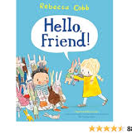  Hello Friend! By Rebecca Cobb |  |  |  | Monster clothes By Daisy Hirst  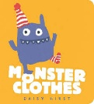 | 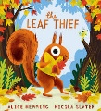  The leaf thief By Alice Hemming |  | 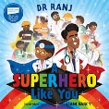  A superhero like you By Dr Ranj |  | 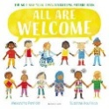  All are welcome By Alexandra Penfold
2 Year Old Texts | 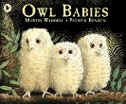  Owl babies By Martin Waddell |  | 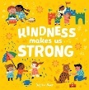  Kindness makes us strong By Sophie Beer |  | 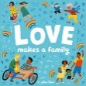  Love makes a family By Sophie Beer | 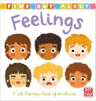  Feelings By Pat-a-cake |  | 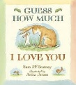  Guess how much I love you By Sam Mcbartney |  | Dear Zoo By Rod Campbell  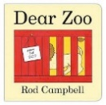
Dev Matters | Enjoy sharing books with an adult. Pay attention and responds to the pictures or the words. Repeat words and phrases from familiar stories. Ask questions about the book. Makes comments and shares their own ideas. Develop play around favourite stories using props. Notice some print, such as the first letter of their name, a bus or door number, or a familiar logo. Listen to simple stories and understand what is happening, with the help of the pictures. (B-3)  Understand the five key concepts about print: - print has meaning - the names of the different parts of a book - print can have different purposes - page sequencing - we read English text from left to right and from top to bottom. Engage in extended conversations about stories, learning new vocabulary. Enjoy listening to longer stories and can remember much of what happens. (3-4)
Maths | Counting 2 |  |  |  | Subitising 1 |  | Pattern 2 |  | Shape, space and measure 2
2 year old focus activities | Baa baa black sheep rhyme and puppet |  |  | Small world animals and blocks (tuff tray) | Guess who story By Pam Eyres | Ducks and frogs tuff tray | Patterned collage pictures |  | Rainbow shape boxes (tuff tray)
Dev Matters | Take part in finger rhymes with numbers. Compare amounts, saying ‘lots’, ‘more’ or ‘same’. Counting-like behaviour, such as making sounds, pointing or saying some numbers in sequence. Count in everyday contexts, sometimes skipping numbers - ‘1-2-3-5.’ Notice patterns and arrange things in patterns. (B-3)  Say one number for each item in order: 1,2,3,4,5. Show ‘finger numbers’ up to 5. Experiment with their own symbols and marks as well as numerals. Extend and create ABAB patterns – stick, leaf, stick, leaf. Notice and correct an error in a repeating pattern. (3-4)
Understanding the World | Nature self portraits | Nature wands |  |  | Branch painting | Bark Tree Rubbing | Leaf puppets |  | Outdoor fall parachute
Dev Matters | Explore materials with different properties. Explore natural materials, indoors and outside. Explore and respond to different natural phenomena in their setting and on trips. (B-3)  Use all their senses in hands-on exploration of natural materials. Explore collections of materials with similar and/or different properties. Talk about what they see, using a wide vocabulary. Begin to understand the need to respect and care for the natural environment and all living things. (3-4)
Expressive arts and design | 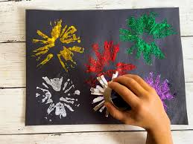  Firework pictures | 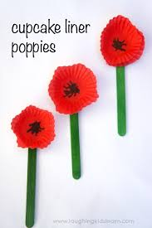  Poppy Pictures |  |  | 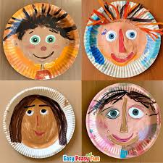  Self Portraits | 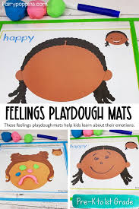  Playdough faces/emotions | 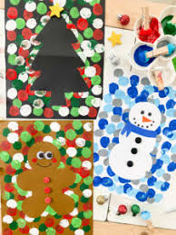  Christmas cards |  | 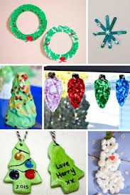  Christmas artwork
Dev Matters | Notice patterns with strong contrasts and be attracted by patterns resembling the human face. Start to make marks intentionally. Explore paint, using fingers and other parts of their bodies as well as brushes and other tools. Express ideas and feelings through making marks, and sometimes give a meaning to the marks they make. Explore different materials, using all their senses to investigate them. Manipulate and play with different materials. Use their imagination as they consider what they can do with different materials. (B-3)  Explore different materials freely, in order to develop their ideas about how to use them and what to make. Develop their own ideas and then decide which materials to use to express them. Join different materials and explore different textures. Create closed shapes with continuous lines and begin to use these shapes to represent objects. Draw with increasing complexity and detail, such as representing a face with a circle and including details. Show different emotions in their drawings and paintings, like happiness, sadness, fear etc. Explore colour and colour-mixing. (3-4)(
Music | Happy-bring the noise  Learning Focus: Pulse, Pitch, Tempo, Dynamics  Themes: PSHE, Emotions, self-belief
Dev Matters | Show attention to sounds and music. Respond emotionally and physically to music when it changes. Move and dance to music. Explore their voices and enjoy making sounds. Make rhythmical and repetitive sounds. Explore a range of sound-makers and instruments and play them in different ways. (B-3)  Listen with increased attention to sounds. Remember and sing entire songs. Sing the pitch of a tone sung by another person (‘pitch match’). Sing the melodic shape (moving melody, such as up and down, down and up) of familiar songs. Create their own songs or improvise a song around one they know. (3-4)

