Nursery Medium Term Planning Spring 2 – Tiny T-Rex Adventures

 | Week 1 | Week 2 |  |  | Week 3 | Week 4 | Week 5 |  | Week 6
Characteristics of Effective Learning | Lenny Lion’s learning zoo  Go for it Gorilla, Exploring Elephant, I know Rhino, Proud Peacock, Concentrating Crocodile, Persevering Parrot, Choosing Chimp, Creative Chameleon, Slinky Linky Snake
Communication & Language | Miss Molly had a dolly   |  |  |  | One, Two buckle my shoe  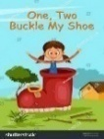 |  | Pat a cake  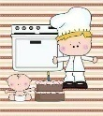
Dev Matters | Enjoy singing, music and toys that make sounds. Enjoy songs and rhymes, tuning in and paying attention. Join in with songs and rhymes, copying sounds, rhythms, tunes and tempo. Say some of the words in songs and rhymes. Copy finger movements and other gestures. Join in with songs and rhymes, making some sounds. Enjoy and take part in action songs, such as ‘Twinkle, Twinkle Little Star’. (B-3)  Sing a large repertoire of songs. Develop their phonological awareness, so that they can: - spot and suggest rhymes - count or clap syllables in a word - recognise words with the same initial sound, such as money and mother. Remember and sing entire songs. Sing the pitch of a tone sung by another person (‘pitch match’). Sing the melodic shape (moving melody, such as up and down, down and up) of familiar songs. Create their own songs or improvise a song around one they know. (3-4)
Phonics | U-Umbrella | R-rainbow |  |  | H-helicopter | B-bear | F-flamingo |  | L-lollipop
2 year old focus activity | Dinosaurs in gloop | Puppets and stories |  |  | Dough disco | Science garden exploring | Scarves and music |  | What’s in the box
WellComm | Big Book | Big Book |  |  | Big Book | Big Book | Big Book |  | Big Book
Dev Matters | Copy your gestures and words. Play with increasing confidence on their own and with other children, because they know their key person is nearby and available. Understand simple questions about ‘who’, ‘what’ and ‘where’ (but generally not ‘why’). (B-3)  Understand position through words alone – for example, “The bag is under the table,” – with no pointing. Explore colour and colour-mixing. (3-4)
Personal, Social and Emotional Development | Jigsaw  Everybody’s body | Jigsaw  We like to move it, move it! |  |  | Jigsaw  Food glorious food | Jigsaw  Sweet dreams | Jigsaw  Keeping clean |  | Jigsaw  Stranger danger
2 Year Old focus activities | Goldilocks and the three bears story sack | 5 little speckled frogs song sack |  |  | Mirror play | Musical instruments | Train track (turn taking) |  | Emotion pictures
Dev Matters | Engage with others through gestures, gaze and talk. Be increasingly able to talk about and manage their emotions. Notice and ask questions about differences, such as skin colour, types of hair, gender, special needs and disabilities, and so on. Develop friendships with other children. Safely explore emotions beyond their normal range through play and stories. Are talking about their feelings in more elaborated ways: “I’m sad because...” or “I love it when ...”. Gaze at faces, copying facial expressions and movements like sticking out their tongue. Make eye contact for longer periods. Watch someone’s face as they talk. Start to say how they are feeling, using words as well as actions. (B-3)  Talk about their feelings using words like ‘happy’, ‘sad’, ‘angry’ or ‘worried’. Begin to understand how others might be feeling. Become more outgoing with unfamiliar people, in the safe context of their setting. Can start a conversation with an adult or a friend and continue it for many turns. (3-4)
Physical Development | Yum Yum (HM) | Dance and drawing 4 – the hump (SWW) |  |  | Smiley brush brush (HM) | Dance and drawing 4a (SWW) | Munch crunch 5 a day (HM) |  | Dance and drawing 4b (SWW)
Dev Matters | Enjoy moving when outdoors and inside. Gradually gain control of their whole body through continual practice of large movements, such as waving, kicking, rolling, crawling and walking. Clap and stamp to music. Enjoy starting to kick, throw and catch balls. Walk, run, jump and climb – and start to use the stairs independently. (B-3)  Skip, hop, stand on one leg and hold a pose for a game like musical statues. Use large-muscle movements to wave flags and streamers, paint and make marks. Continue to develop their movement, balancing, riding (scooters, trikes and bikes) and ball skills. (3-4)
Literacy | Amazing by Steve Antony  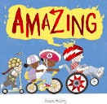 |  |  |  | 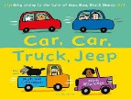  Car, Car, Truck, Jeep by Nick Sharratt | 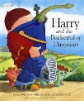  Harry and the bucketful of dinosaurs by Ian Whybrow |  | 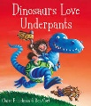  Dinosaurs love underpants by Claire Freedman |  | 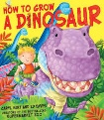  How to grow a dinosaur by Caryl Hart
2 Year Old Texts | 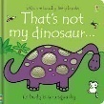  That’s not my dinosaur by Fiona Watt |  | 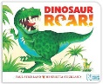  Dinosaur Roar! By Henrietta Stickland |  | 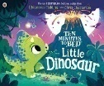  Ten minutes to bed little dinosaur by Rhiannon Fielding | 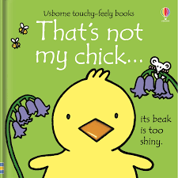  That’s not my chick by Fiona Watt |  | 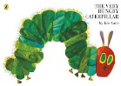  The very hungry caterpillar by Eric Carle |  | Dinosaurs Galore by Giles Andrea  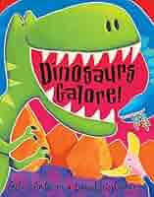
Dev Matters | Enjoy sharing books with an adult. Pay attention and responds to the pictures or the words. Repeat words and phrases from familiar stories. Ask questions about the book. Makes comments and shares their own ideas. Develop play around favourite stories using props. Notice some print, such as the first letter of their name, a bus or door number, or a familiar logo. Listen to simple stories and understand what is happening, with the help of the pictures. (B-3)  Understand the five key concepts about print: - print has meaning - the names of the different parts of a book - print can have different purposes - page sequencing - we read English text from left to right and from top to bottom. Engage in extended conversations about stories, learning new vocabulary. Enjoy listening to longer stories and can remember much of what happens. (3-4)
Maths | Counting 4 |  |  |  | Shape, space and measure 4 |  | Subitising 3 |  | Comparison 2
2 year old focus activities | 3 little men in a flying saucer |  |  | Teddy bears picnic tuff tray | Train track and billy goats gruff | Humpty dumpty rhyme and blocks | The very hungry caterpillar tuff tray |  | Coloured spots and numeracy bears
Dev Matters | Take part in finger rhymes with numbers. Compare amounts, saying ‘lots’, ‘more’ or ‘same’. Counting-like behaviour, such as making sounds, pointing or saying some numbers in sequence. Count in everyday contexts, sometimes skipping numbers - ‘1-2-3-5.’ Notice patterns and arrange things in patterns. (B-3)  Say one number for each item in order: 1,2,3,4,5. Show ‘finger numbers’ up to 5. Experiment with their own symbols and marks as well as numerals. Extend and create ABAB patterns – stick, leaf, stick, leaf. Notice and correct an error in a repeating pattern. (3-4)
Understanding the World | Digging for dinosaur bones | Sink and float water play |  |  | Dinosaur swamp | Dinosaur stomp (moving like different dinosaurs) | Spring sensory walk |  | Planting seeds
Dev Matters | Explore materials with different properties. Explore natural materials, indoors and outside. Explore and respond to different natural phenomena in their setting and on trips. (B-3)  Use all their senses in hands-on exploration of natural materials. Explore collections of materials with similar and/or different properties. Talk about what they see, using a wide vocabulary. Begin to understand the need to respect and care for the natural environment and all living things. (3-4)
Expressive arts and design | 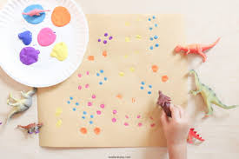  Dinosaur printing | 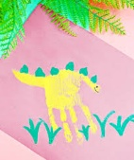  Dinosaur handprints |  |  | 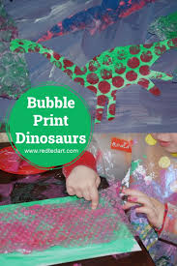  Bubble wrap dinosaurs | 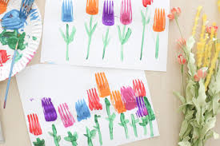  Fork tulips | 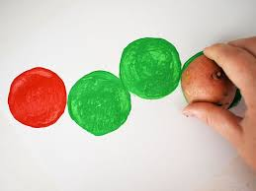  Potato printing caterpillars |  | 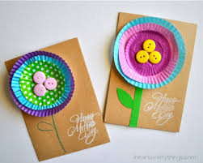  Mother’s day cards
Dev Matters | Notice patterns with strong contrasts and be attracted by patterns resembling the human face. Start to make marks intentionally. Explore paint, using fingers and other parts of their bodies as well as brushes and other tools. Express ideas and feelings through making marks, and sometimes give a meaning to the marks they make. Explore different materials, using all their senses to investigate them. Manipulate and play with different materials. Use their imagination as they consider what they can do with different materials. (B-3)  Explore different materials freely, in order to develop their ideas about how to use them and what to make. Develop their own ideas and then decide which materials to use to express them. Join different materials and explore different textures. Create closed shapes with continuous lines and begin to use these shapes to represent objects. Draw with increasing complexity and detail, such as representing a face with a circle and including details. Show different emotions in their drawings and paintings, like happiness, sadness, fear etc. Explore colour and colour-mixing. (3-4)(
Music | Hands in the air  Learning Focus: Careful listening, pulse, rhythm  Themes: PE, science, The human body
Dev Matters | Show attention to sounds and music. Respond emotionally and physically to music when it changes. Move and dance to music. Explore their voices and enjoy making sounds. Make rhythmical and repetitive sounds. Explore a range of sound-makers and instruments and play them in different ways. (B-3)  Listen with increased attention to sounds. Remember and sing entire songs. Sing the pitch of a tone sung by another person (‘pitch match’). Sing the melodic shape (moving melody, such as up and down, down and up) of familiar songs. Create their own songs or improvise a song around one they know. (3-4)

